
Business Question and Visualization Report

Date | 07 October 2026
Team ID
Project Name | India’s Agricultural Crop Production Analysis (1997–2021)
Maximum Marks | 5 Marks

Visualization development refers to the process of creating graphical representations of data to facilitate understanding, analysis, and decision-making. The goal is to transform complex datasets into visual formats that are easy to interpret, enabling users to gain insights and make informed decisions. Visualization development involves selecting appropriate visual elements, designing layouts, and using interactive features to enhance the user experience. This process is commonly associated with data visualization tools and platforms, and it plays a crucial role in business intelligence, analytics, and reporting
Business Questions and Visualisation
The process involves defining specific business questions to guide the creation of meaningful and actionable visualizations in Tableau. Well-framed questions help in identifying key metrics, selecting relevant data, and building visualisation that provide insights.
1. How has agricultural crop production changed over the years?
Visualization:
Line Chart – Year-wise Crop Production
Description:
A line chart is used to analyse the change in agricultural crop production over different years. It helps identify overall production trends and changes over the period from 1997–98 to 2020–21.
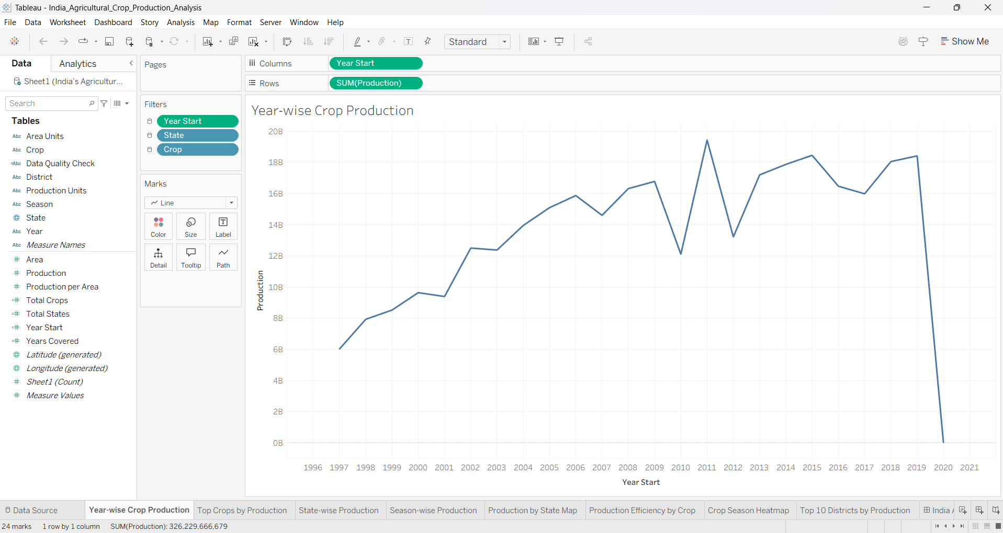

2. Which crops contribute the most to agricultural production?
Visualization:
Horizontal Bar Chart – Top 10 Crops by Production (Tonnes)
Description:
A horizontal bar chart is used to compare the production of different crops. The visualization focuses on the top 10 crops based on production measured in tonnes, making it easier to identify the crops with the highest production.
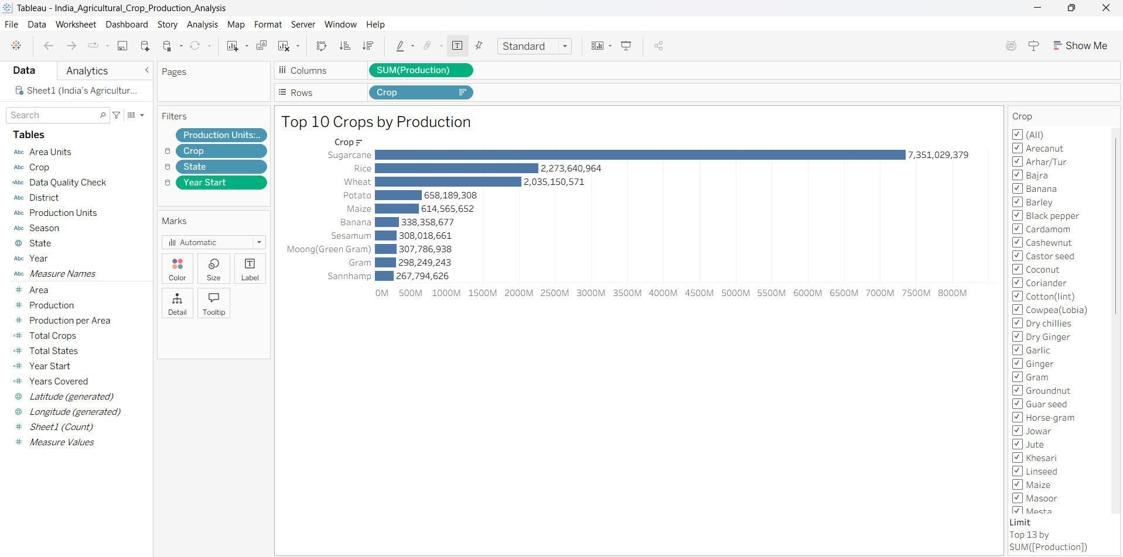

3. Which states have the highest agricultural production?
Visualization:
Horizontal Bar Chart – State-wise Agricultural Production
Description:
A horizontal bar chart is used to compare agricultural production across different states. Production is measured in tonnes, allowing the states with higher and lower production levels to be compared easily.
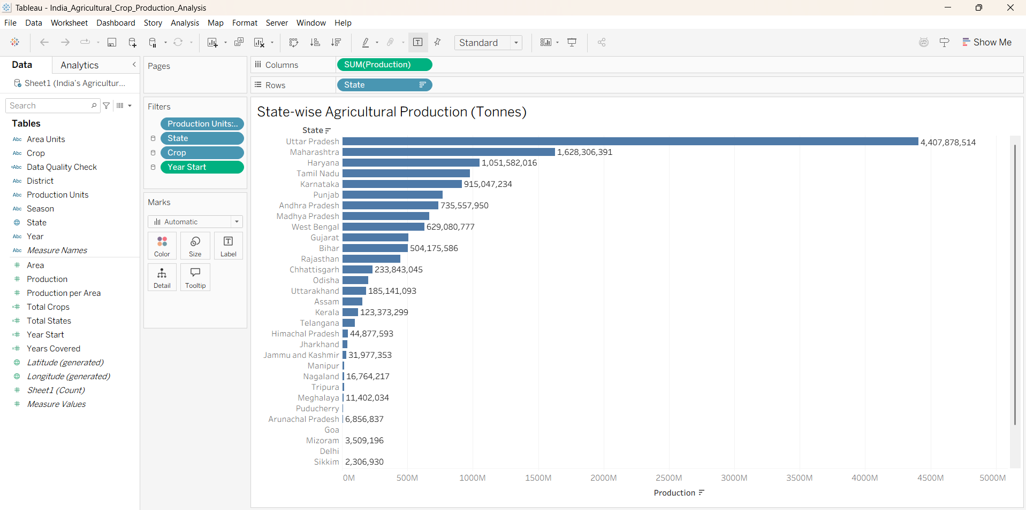

4. Which seasons contribute the most to agricultural production?
Visualization:
Bar Chart – Season-wise Agricultural Production
Description:
A bar chart is used to compare agricultural production across different seasons. It helps identify which seasons contribute the most to overall agricultural production in the dataset.
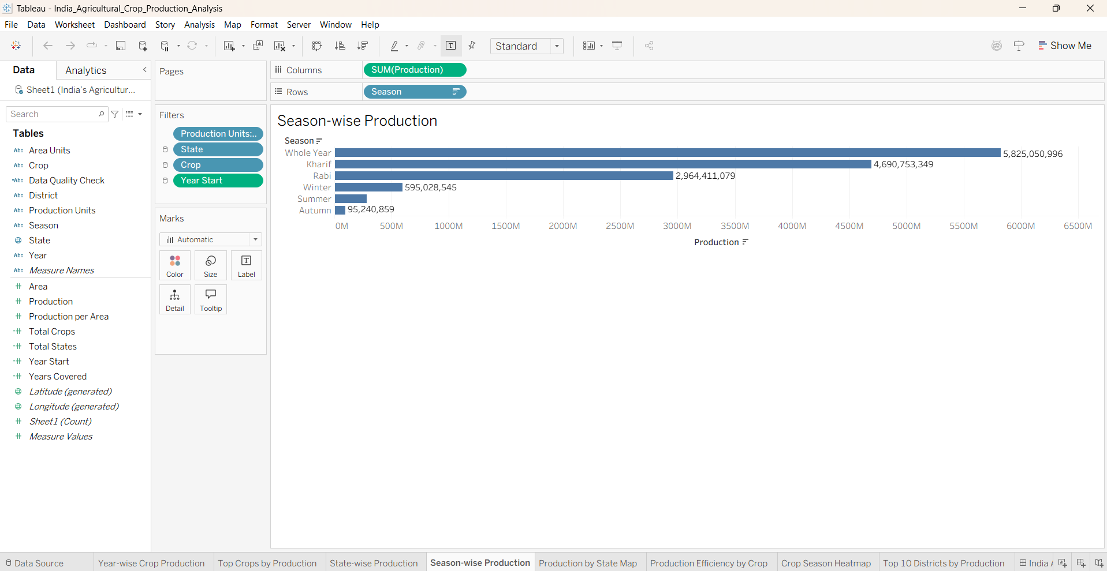

5. How is agricultural production distributed across different states in India?
Visualization:
Map – Agricultural Production by State
Description:
A map visualization is used to show the geographical distribution of agricultural production across different states in India. It provides a quick visual comparison of production levels between states.
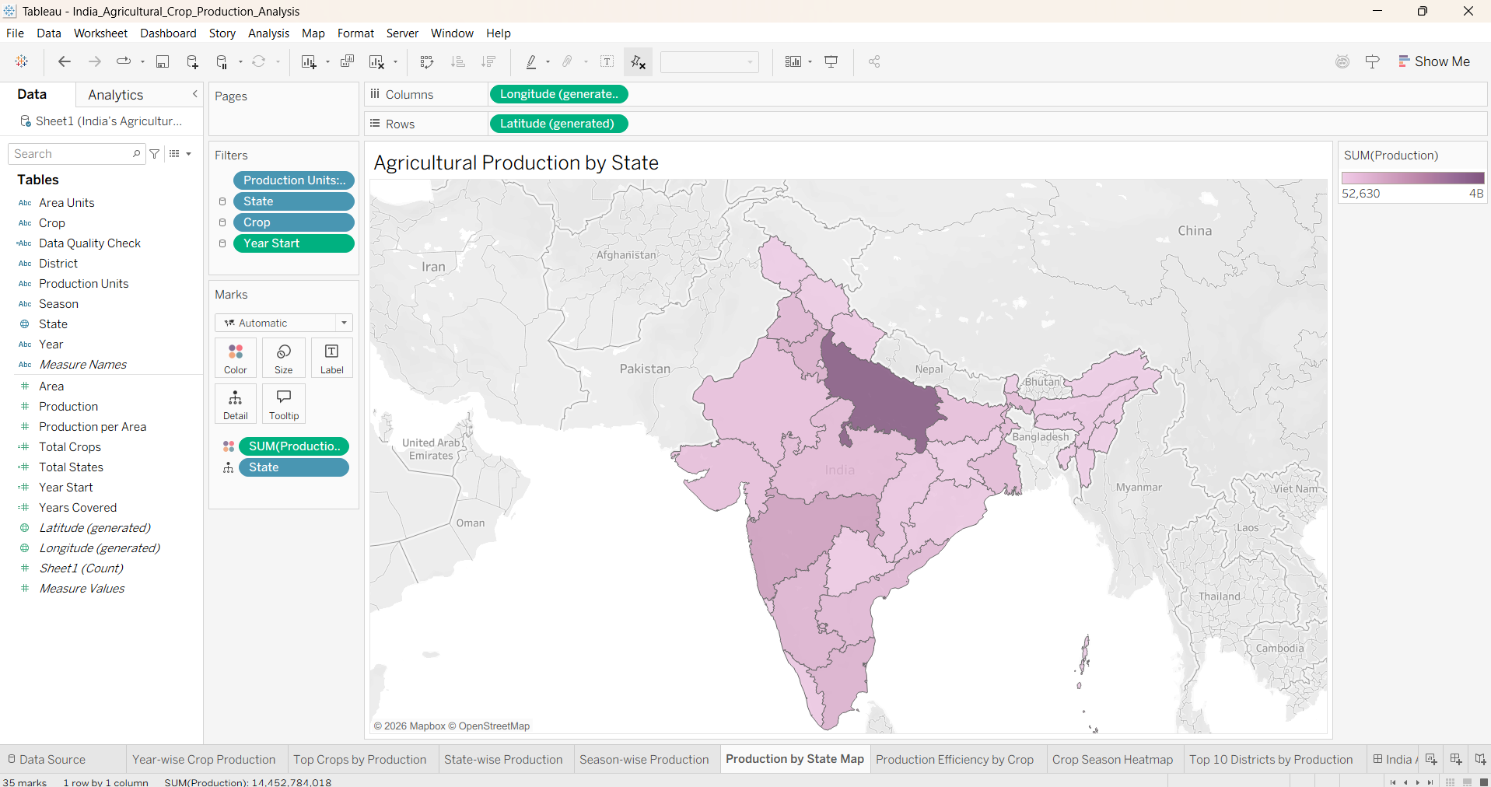

6. Which crops show the highest production efficiency relative to area?
Visualization:
Horizontal Bar Chart – Top 10 Crops by Production Efficiency
Description:
A horizontal bar chart is used to compare the production efficiency of different crops based on production relative to the cultivated area. The visualization highlights the top 10 crops with the highest production efficiency. 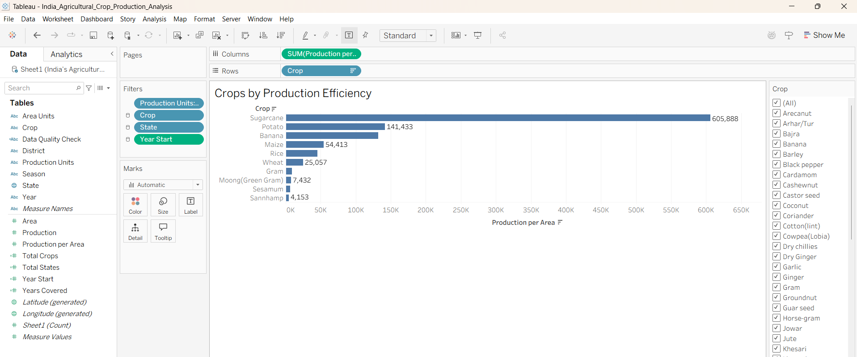
7. How does crop production vary across different seasons?
Visualization:
Heatmap – Crop Season Heatmap
Description:
A heatmap is used to analyse the relationship between crops and seasons. It makes it easier to identify variations in production across different crop-season combinations.
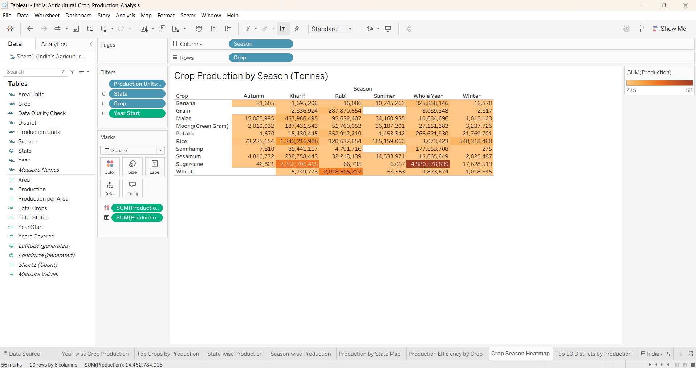

8. Which districts have the highest agricultural production?
Visualization:
Horizontal Bar Chart – Top 10 Districts by Production
Description:
A horizontal bar chart is used to compare agricultural production across districts. The visualization focuses on the top 10 districts by production, helping identify the districts with the highest production levels.
